# Who Cares About Fågeltofta? Failing to Grieve Landscapes in Transition

### Li Jönsson and Kristina Lindström

Standing in the middle of a field in Fågeltofta, Sweden, we see an open landscape featuring fields with different crops, grassing cows, some houses, farms, a church, and a closed petrol station. Cars rush through the village heading somewhere else. At first glance, there is nothing striking about this place. However, what is not possible to see with the naked eye is that Fågeltofta is an area that holds a lot of hope for transitioning into a post-fossil society. If we could look below the growing crops and grass, underneath our wellies, we would discover vanadium. This is a hard, silvery-grey, malleable transition metal classified by the European Union as critical for future innovation, meant to be used in batteries storing sun and wind energy. Vanadium is therefore considered important for enabling continued mobility in a fossil-free society. For those living in the area, harvesting vanadium would radically alter both their local landscape and living conditions as it would require mines to open.

As researchers drawing from participatory design, feminist techno-science, and cultural geography, we will give an account of an ongoing research project meant to mobilize a heterogeneous understanding of hope as well as loss in a transition towards a fossil-free society. Our interest in vanadium was initiated by a curiosity about how to productively engage with the disruption of a landscape, literally a field, in the name of future innovation. This was explored through an installation called *Clayworks*, connected to a series of workshops where we invited inhabitants to engage with the issue of landscapes in transition using clay from Fågeltofta.

In this chapter, we will discuss Fågeltofta as a potential future ‘shadow place’[1] that creates what can be described as a ‘pre-solastalgic state’.[2] Drawing on our engagement with *Clayworks*, we will discuss the need for and potential failure to grieve landscapes in transition. We will focus on this failure as we argue it reaches far beyond this event into contemporary accounts of how to understand and approach the transition into a post-carbon society. In other words, we believe that there is something important to learn if we approach this work as a potential failure.

## Fågeltofta — A Future Shadow Place?

In 1868, the area around Fågeltofta was hit by two disasters. Spring came early that year, and the animals were released to graze on the green meadows. As per usual, the farmers sowed their crops when the soil was ready for the small seeds to start sprouting, but the plants quickly froze as winter returned with full force at the end of May. Later that year, this abrupt weather change had large consequences and led to famine. Due to the almost non-existent harvest, the farmers also struggled to imburse their lease of land. The landowner, Count Hamilton, seized the opportunity to take control of the land himself and terminated their contracts. The farmers lost not only their land as their source of food but also their houses, which were taken down, clay brick by clay brick. Some of them were rebuilt by the Count to provide houses for lumbermen. Other houses disappeared, leaving no ruins or marks due to being built with the clay from the surrounding fields. Today, a generation of newer houses make up the village, while the local church predating the disasters stands in solitude, surrounded by fields instead of houses.

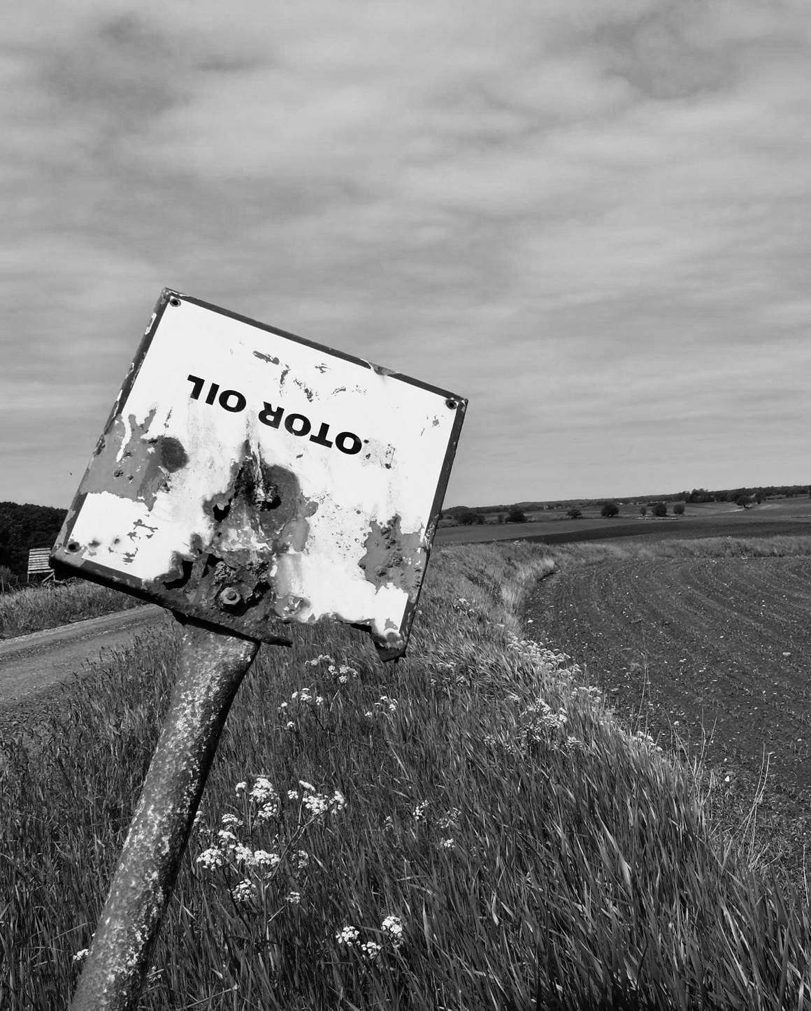

Figure 10.1: A rusty upside-down sign reading ‘motor oil’, standing outside the village of Fågeltofta, where test drilling for vanadium might be done. Photo credit: Li Jönsson.

The land surrounding Fågeltofta and the clay that was once used to build the local villages has gained new value. The aluminium slate that hides in the soil is predicted to contain vanadium. Finding and extracting it requires special skills, a lot of capital, and access to large areas of land. In Sweden, therefore, anyone who meets the conditions to exploit deposits can be granted a permit, under the so-called Mineral Act (a legislation about the right to undertake exploration and exploitation that came into force in 1992), regardless of who owns the land. Local citizens have gathered to protest these plans, partly doubting claims being made that this is done for environmental reasons. One of the biggest concerns and worries for locals has been the fact that one literally loses the right to land and properties if the chief mining inspector grants a permit for the exploration. In Fågeltofta, an exploration permit has been granted, but no actual test drilling has yet been done. The locals are waiting in uncertainty regarding the future of the landscapes on which their homes stand.

Although this might seem to echo the historical narrative of a place with unjust power distributions and unsustainable processes, we might also recognize the dilemma that if mines are not opened here, then where might they be opened? What other places will become what Australian philosopher and feminist Val Plumwood[3] refers to as shadow places? These are places that remain invisible but supply the rest of the world with energy, raw materials, and other resources. The existence of many loved places and the ways of living they support are, in other words, enabled by shadow places. Similarly, vanadium inscribes a hope for the continued high energy consumption that allows us not to have to change much in our everyday lives.

## Clayworks

To stage and facilitate a hands-on discussion in relation to some of the above dilemmas, we created the installation *Clayworks* (Figure 10.2). The installation invited people passing by to make a clay brick by following some simple instructions. They were asked to mark their brick with the name of a place that faces a potential transition and might be in need of care.

We hosted the installation in a time-worn shabby shed during the yearly local artisan fair and gathered a pile of clay from Fågeltofta. The clay had been unearthed by a farmer from Fågeltofta and possibly contained vanadium. The story of Fågeltofta’s two disasters and the prospect for future mining was nailed to the shed. *Clayworks* was installed for six months, and occasionally, some of our project team would facilitate clay brick workshops announced to the public through the organising art fair.

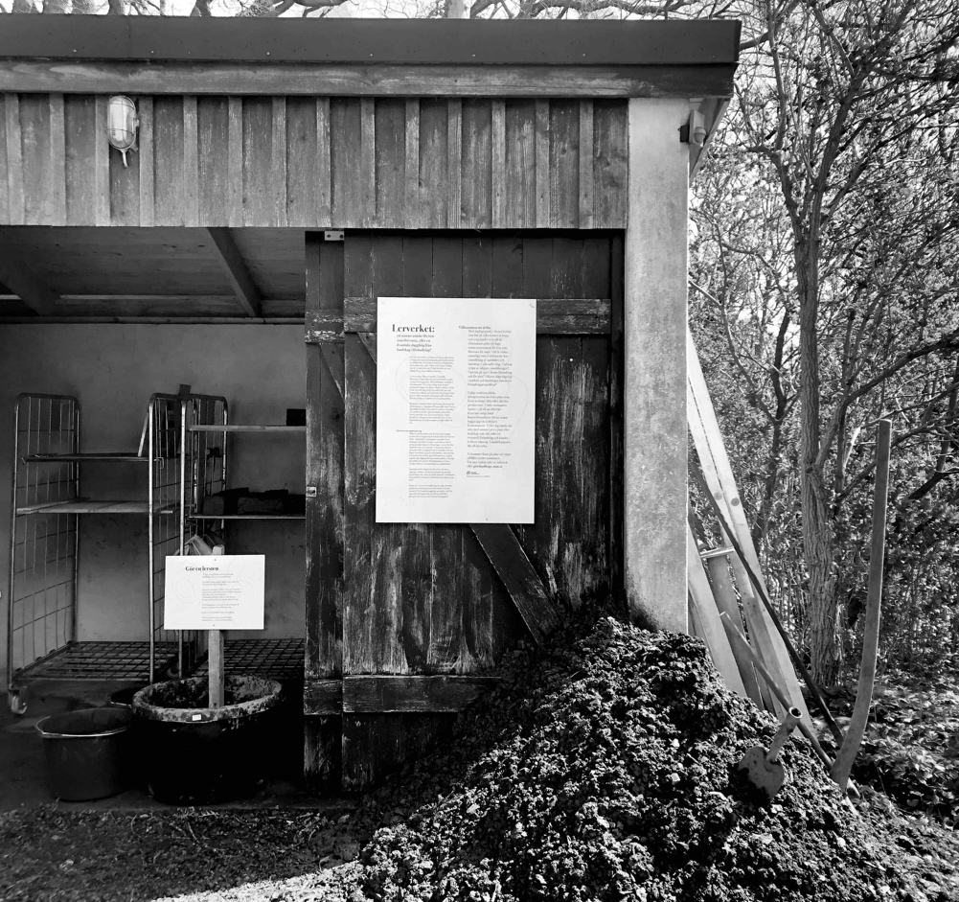

Figure 10.2: *Clayworks* exhibited during ART WALK 2021 at Tjörnedala Art Gallery. Photo credit: Li Jönsson.

In *Clayworks*, our attempt was to draw attention and attachments to the actual place, history, and future by inviting participants to literally touch, tinker with, and handle the local clay and form it into bricks. The bricks resembled a memorial of the village that disappeared. This narrative of loss in the past was interwoven with contemporary worries of places and landscapes in transition through the invitation to inscribe each clay brick with the name of a place participants cared for.

Several of the people who took part in making clay bricks shared stories and worries about the experience of places in transition. Some stories were about already experienced changes in landscapes. A couple carved the name of an overgrown brook close to their house and used it to raise concerns of how drainage for agricultural land reclamation has negatively affected local biodiversity. Many carved names of coastal settlements and expressed worries about how the coastlines currently suffered from erosion and potential rising sea levels in the future. A woman voiced her concern about the global shortage of sand and gravel used for construction as she carved the name of a local gravel pit that she had witnessed growing lately. Some people had difficulty coming up with any particular place. Instead, they would inscribe names of names of well-known beautiful places, such as beaches and nature reserves, popular with locals and tourists (Figure 10.3).

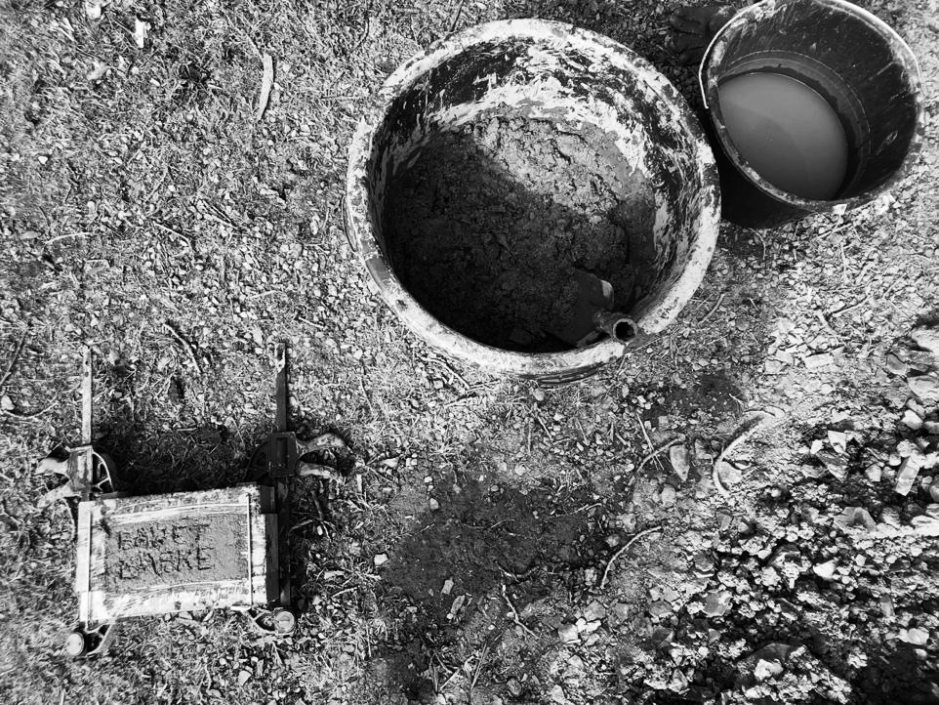

Figure 10.3: One of the clay bricks in the making inscribed with ‘Baskebadet’, which is one of the popular beaches in the area. Photo credit: Li Jönsson.

Six months passed. When we were about to gather the bricks that had dried in the sun, we felt a sense of failure. Had we managed to cultivate care, attachments, and commitments to places and landscapes such as Fågeltofta that are at risk of irreparable destruction and that too few people know about or have visited? Or, was something else required for cultivating care and commitment? A question posed by a resident in Fågeltofta echoed in our heads: Who cares about Fågeltofta?

## Failure to Grieve

*Clayworks* is part of a three-year project concerned with mobilising a heterogeneous understanding of hope as well as grief in a transition towards a fossil-free society. In *Clayworks*, our particular focus was on landscapes that are going through or are about to undergo changes that might cause worry and distress for people who care about those places. The main narrative of *Clayworks* was centred on Fågeltofta, its past, and its potential future.

In the context of climate change, species extinction, and ecological damage caused by human activities, several scholars argue for the need to rework how we cope with losses and to develop a more nuanced understanding of the kind of work grief can do.[4] For example, Cunsolo and Landman[5] argue for moving beyond a Freudian understanding of mourning, which suggests that successful mourning implies overcoming that which has been lost to become whole again. A failure to do so would imply a state of melancholia, preventing a person from moving on. Coping with the loss of species or landscapes caused by human activity might, however, suggest other understandings of mourning and what it means to move on. Influenced by Butler’s[6] articulation of grief as transformative, Cunsolo and Landman[7] argue that ecological grief is less about forgetting or overcoming that which has been lost and more about recognising one’s attachments to it. To be able to ‘move on’ then requires allowing oneself to be transformed. For example, the loss of a place that you have a strong connection to will also change who you are.

To capture this kind of ‘existential distress’[8] experienced by people when ‘directly confronted by unwelcome change in their loved home environment’,[9] Albrecht articulated the concept of solastalgia. The word solastalgia is a neologism based on the word nostalgia. Albrecht describes nostalgia as a kind of homesickness experienced when being away from home, whereas solastalgia refers to ‘the homesickness you have when still being at home’.[10] Although the concept of solastalgia is highly relevant in relation to the narratives that were enacted through *Clayworks*, these narratives does not fit perfectly within the definition of solastalgia. Instead, it can be understood as an expression of a ‘pre-solastalgic state’[11] that enquires into worries ‘about the possible passing of the familiar and its replacement by that which does not sit comfortably within one’s sense of place’.[12] In other words, the distress experienced in the context of Fågeltofta and many of the other narratives that emerged in *Clayworks* were not necessarily about something that had already happened but concerned the distress of that which might be about to happen.

Looking back at the narrative of both past and potential future losses of Fågeltofta, it is evident that there are similarities but also differences between them. There are similarities in the sense that both narratives involve experienced or potential loss of landscapes with implications for people living there. There are, however, also differences that might suggest different kinds of emotional or affective responses, such as how the crop failure caused by cold weather is in the past, whereas the plan for vanadium mines is an anticipated future. Furthermore, the crop failure and following famine were not self-inflicted in the same ways the future mining plans are.

Although grieving is always hard and requires work, it is easier to grieve losses that have happened and where we do not see ourselves as culpable. But how do we move from these recognisable forms of grief towards a grief concerned with losses that are ongoing, uncertain, and caused by human activities? How do we strike up practices that can support pre-solastalgic grief?

Perhaps we can find some insights in what Barr describes as ‘resistant ecological mourning’.[13] This articulation builds on the work of Rae, who describes a kind of mourning that resists bringing grief through catharsis and instead provokes questions on the causes of past or potential future loss and which can act as a ‘warning about future losses that could occur given the continuation of the status quo’.[14] Drawing on her own and others’ artistic practices, Barr[15] argues for narratives and artistic expressions that acknowledge and bring past losses into the present, not to simply remember that which has been lost but as a reminder of the continued devastation that will take place unless there is action and change. The difficulty here is that we often fail to imagine what that change could be and find alternatives to the well-trodden modernistic path. Furthermore, a defining feature of solastalgia is the personal and political powerlessness in the lived experience of environmental change,[16] echoed by some of the inhabitants of Fågeltofta along with others expressing a need for resistance in light of risking losing their home place to a future mine.

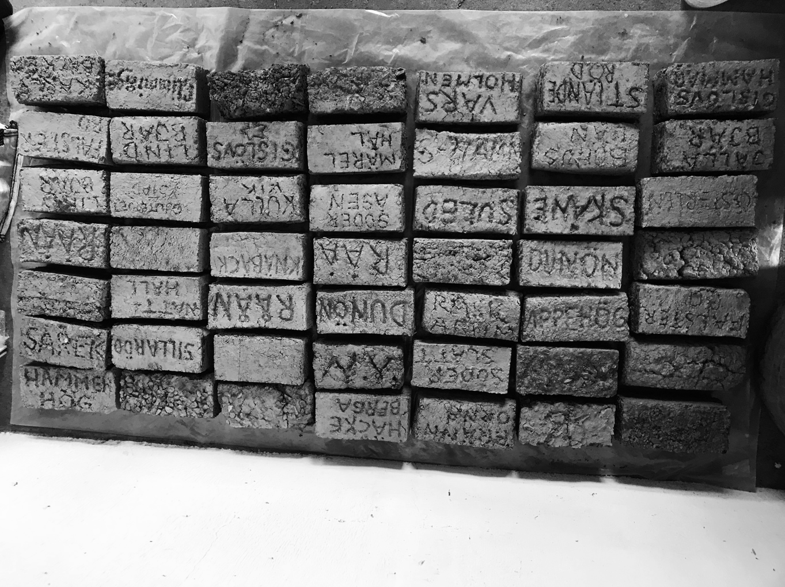

Figure 10.4: Part of the collection of dried clay inscribed with places that participants cared for in multiple ways. Photo credit: Li Jönsson.

Seeing the drying clay bricks next to each other, names of potential future shadow places like Fågeltofta were positioned next to names of places (Figure 10.4) that we can understand as beautiful and cherished, places to which the individual participants had a strong sense of connection and belonging. This might not be surprising given that we asked participants to write down the name of a place they cared for. Nonetheless, the ways in which different locations and experiences were brought into *Clayworks* often enacted these places as singular, and we often failed to recognize the ways in which these places interconnected. Although the bricks were placed next to each other to indicate their connectedness, we failed to account for the ways in which caring for one place might have implications for other places. Plumwood argues that ‘recovering a storied sense of land and place is a crucial part of the restoration of meaning’.[17] However, she argues, if we treat places of belonging as singular, without recognising their dependence on other places, we run the risk of generating a false sense or understanding of these places and what is at stake in our care for them.

## Concluding Discussion

In this chapter, we have looked at the failure to attend to, care for, and recognize places in transition. We have responded to this by aiming to strike up practices of pre-solastalgic grief. What characterizes this form of grief is that it is anticipatory, and that the potential loss is implicated in our ways of living. In other words, it is a grief concerned with a potential future loss that we, to some extent, are responsible for, even though we often lack a sense of agency in the matter. In line with Cunsolo and Landman,[18] we argue that grieving successfully in this context would not simply imply accepting the loss and moving on. Instead, we argue for grieving practices that invite hesitation regarding what is at stake in moving on and instead open up for transformation.

To support this form of grief, we argue for narratives and material engagements that are situated in specific places and draw their histories and potential future together. Importantly, we also argue for extending this care and concerns beyond the singular place, individual, animal, or plant and instead recognising the ways in which places and ways of living are interconnected. In many ways, our collective failure seems to be in the resistance to see how imaginaries of becoming fossil-free contribute to the creation of new shadow places and the destruction of other lifeworlds. The question of ‘who cares about Fågeltofta?’ can be expanded to other places with similar fates — multiple potential future shadow places. Following Plumwood, there is much to be said for having love for a specific individual, animal, or place, but this is simply not enough. To nurture more ethical and justice-driven worlds to grow, we need to recognize the fate of Fågeltofta as a shared responsibility connected to our current practices that construct these harmed places and their beings.

We would not say that our work in *Clayworks* fully managed to support this collective and transformative form of grief. It should rather be seen as a first sketchy attempt to collectively rehearse how to practise pre-solastalgic grief. There is much to learn from our failures.

On a final note, calls for how to deal with vast ecological damage are urgent, and our attempt to respond with the slow pace of lingering and the hard work required to grieve might in many ways seem contradictory to the need for action. Comparably, the response of opening mines to harvest materials in the name of eco-innovation might be seen as a direct and more productive contribution to the fossil-free transition. Although problematic, this response is still a form of self-preservation of our modern selves and lifestyles — a melancholic state of being where ordinary routines are to be conserved. In light of this, we need to ask if it is reasonable to sacrifice Fågeltofta to preserve our current lifestyle and allow it to become a shadow place. Our response, to strike up practices of pre-solastalgic grief, is meant to invite such questions of sacrifice to become more publicly available, to allow for other considerations of urgency to be balanced, to problematize the disengagements of our fossil-dependent shadows, and to expand the repertoire of possible responses for how to become fossil-free.

## Bibliography

Albrecht, Glenn. ‘Solastalgia and the New Mourning’ in Ashlee Cunsolo and Karen Landman (eds) *Mourning Nature: Hope at the Heart of Ecological Loss and Grief*, Montreal and Kingston: McGill-Queen’s Press, 2017, pp. 292-315.

Barr, Jessica M. ‘Auguries of Elegy: The Art and Ethics of Ecological Grieving’ in Ashlee Cunsolo and Karen Landman (eds) *Mourning Nature: Hope at the Heart of Ecological Loss and Grief*, Montreal and Kingston: McGill-Queen’s Press, 2017, pp. 190-226.

Butler, Judith. *Precarious life: The powers of mourning and violence*, London and New York: Verso Books, 2004.

Cunsolo, Ashlee, and Karen Landman.‘Introduction. To Mourn beyond the Human’ in Ashlee Cunsolo and Karen Landman (eds) *Mourning Nature: Hope at the Heart of Ecological Loss and Grief*, Montreal and Kingston: McGill-Queen’s Press, 2017, pp. 3-26.

Head, Lesley. *Hope and Grief in the Anthropocene: Re-Conceptualising Human—Nature Relations*, London and New York: Routledge, 2016.

Plumwood, Val. ‘Shadow places and the politics of dwelling’, *Australian Humanities Review* 44.2 (2008): 139-150.

Rae, Patricia. ‘Introduction: Modernist Mourning’ in Patricia Rae (ed) *Modernism and Mourning*, Lewisburg: Bucknell University Press, 2007, pp. 13-49.

## Acknowledgement

This work is funded by Formas under grant no. 2019-01996.

1. Val Plumwood, ‘Shadow places and the politics of dwelling’, *Australian Humanities Review* 44.2 (2008): 139-150.
2. Glenn Albrecht, ‘Solastalgia and the New Mourning’, in Ashlee Cunsolo and Karen Landman (eds) *Mourning Nature: Hope at the Heart of Ecological Loss and Grief*, Montreal and Kingston: McGill-Queen’s Press, 2017, pp. 292-315.
3. Plumwood, ‘Shadow places and the politics of dwelling’.
4. Ashlee Cunsolo and Karen Landman, ‘Introduction. To Mourn beyond the Human’ in Ashlee Cunsolo and Karen Landman (eds) *Mourning Nature: Hope at the Heart of Ecological Loss and Grief*, Montreal and Kingston: McGill-Queen’s Press, 2017, pp. 3-26; Lesley Head, *Hope and Grief in the Anthropocene: Re-Conceptualising Human–Nature Relations,* London and New York: Routledge, 2016; Albrecht, ‘Solastalgia and the New Mourning’.
5. Cunsolo and Landman, ‘Introduction. To Mourn beyond the Human’.
6. Butler, Judith. *Precarious life: The Powers Of Mourning and Violence,* London and New York: Verso Books, 2004.
7. Cunsolo and Landman, ‘Introduction. To Mourn beyond the Human’.
8. Albrecht, ‘Solastalgia and the New Mourning’, 292.
9. Albrecht, ‘Solastalgia and the New Mourning’, 292.
10. Albrecht, ‘Solastalgia and the New Mourning’, 299.
11. Albrecht, ‘Solastalgia and the New Mourning’, 309.
12. Albrecht, ‘Solastalgia and the New Mourning’, 309.
13. Jessica M. Barr, ‘Auguries of Elegy: The Art and Ethics of Ecological Grieving’ in Ashlee Cunsolo and Karen Landman (eds) *Mourning Nature: Hope at the Heart of Ecological Loss and Grief*, Montreal and Kingston: McGill-Queen’s Press, 2017, pp. 190-226.
14. Patricia Rae, ‘Introduction: Modernist Mourning’ in Patricia Rae (ed) *Modernism and Mourning*, Lewisburg: Bucknell University Press, 2007, pp. 13-49.
15. Barr, ‘Auguries of Elegy’.
16. Albrecht, ‘Solastalgia and the New Mourning’.
17. Plumwood, ‘Shadow places and the politics of dwelling’, 1.
18. Cunsolo and Landman, ‘Introduction. To Mourn beyond the Human’.